Readme file for AIST2010 Project Code

Our project work consists of 4 Google Colab files.

1. synthesized.ipynb
2. nokia.ipynb
3. synthesized_bandpass.ipynb
4. Schubert - Impromptu No.3, Op. 90.ipynb

Visualization is generated and the play buttons can be clicked to play all the sounds throughout these programs.

For example:

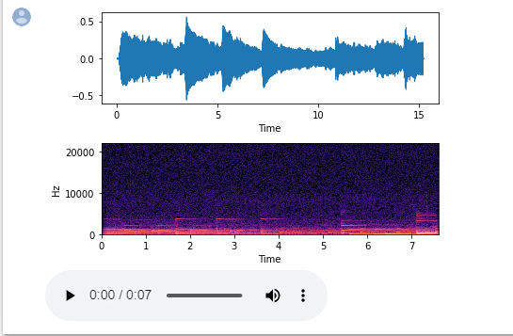

1. synthesized.ipynb

This program is to synthesize a noise from a single frequency sound and performs noise cancellation by PSD approach.

Steps:

1. ran all the code blocks from top to bottom
2. the value of the threshold can be changed in this code block. The higher the threshold, the more signal below the PSD threshold will be removed

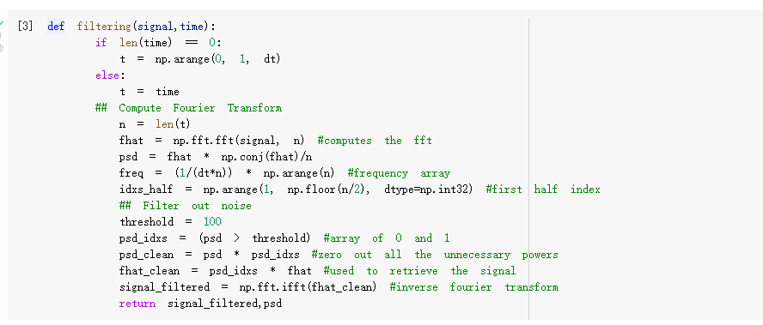

2. nokia.ipynb

This program synthesizes a noisy Nokia ringtone and denoises it by the PSD approach.

Steps:

1. upload the “NOKIA RINGTONE [1994].wav” file provided to Google Colab
2. run all the code blocks from top to bottom
3. the value of the threshold can be changed in this code block. The higher the threshold, the more signal below the PSD threshold will be removed

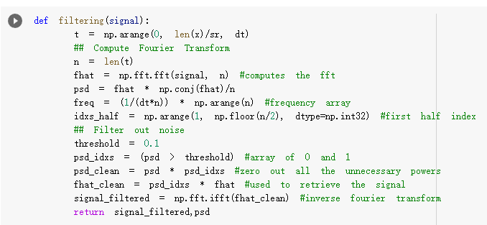

3. synthesized_bandpass.ipynb

This program synthesizes a noise from a single frequency sound and a noisy Nokia ringtone, then denoises them by the Butterworth filter.

Steps:

1. upload the “NOKIA RINGTONE [1994].wav” file provided to Google Colab
2. run all the code blocks from top to bottom
3. the bandwidth is set to just eliminate frequencies outside the frequency range of the two sound signals. The bandwidth can be changed in [0.01995, 0.01996] in this code block, in which the first element indicates the band start and the second element indicates the band stop

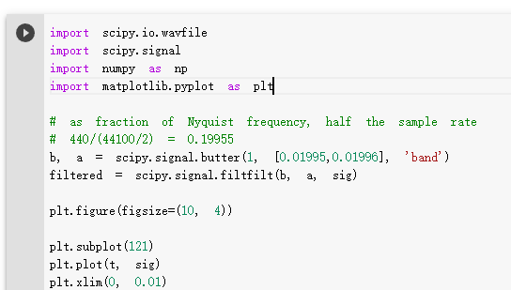

4. Schubert - Impromptu No.3, Op. 90.ipynb

This program uses a real-life piano sound piece recorded by our mobile phone and denoises it in the PSD approach.

Steps:

1. upload the “Franz Schubert - Impromptu No.3, Op. 90(D899).wav” file provided to Google Colab
2. run all the code blocks from top to bottom
3. the value of the threshold can be changed in this code block. The higher the threshold, the more signal below the PSD threshold will be removed

